Odometer / Trip Odometer Indication Display with Key-OFF/ACC Display – CGEA1.3

Functional Description

The purpose of the odometer is to provide the total vehicle distance traveled information to the vehicle operator by means of a digital display located in the instrument cluster.

The purpose of the trip odometer is to provide the vehicle distance traveled since the last user trip reset by means of a digital display located in the instrument cluster.

The Odometer correlates the OdoCount signal and the Operational Mode to display digital representation of distance traveled.

The Trip Odometer correlates the OdoCount signal, Trip_Reset_Cmd (HW) signal and the Operational Mode to display digital representation of distance traveled. Two independent trip odometers will be tracked and displayed as Trip A and Trip B.

The Instrument Cluster will enter Limited Mode upon a Door Ajar or a Key transition to OFF/ACC for a time period. The cluster shall then be capable of displaying the Odometer for a short time period if any of the following occur:

1-button system - the SEL/RESET switch has been pressed
3-button system - any (Info/Setup/Reset) button on the Message Center Switch has been pressed

Interfaces

Interface Context Diagram (I/O Block Diagram)
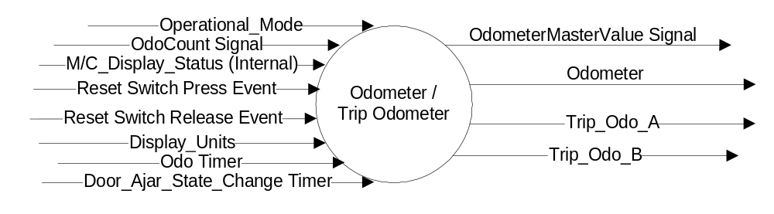Figure 1 Odometer / Trip Odometer Context Diagram

Inputs
      - Operational_Mode
      - M/C_Display_Status
      - Display_Units (English or Metric)
      - Reset Switch Press Event
      - Reset Switch Release Event
      - Odo Timer
      - Door_Ajar_State_Change Timer
      - MUX message on the CAN Bus from the PCM

Table 1.0 OdoCount Signal
Signal Name | Size (bits) | Detail | Units | Res. | Offset | State Encoded | Min | Max
OdoCount | 8 |  | meters | 0.2 | 0 |  | 0(0x0) | 50.8 (0xFE)
 |  | Invalid |  |  |  | 0xFF

- OdoCount Signal value is 256 steps, transition from 254 to 0 is two steps for the cluster. A 255 (0xFF) is used only in error handling of invalid data from the PCM.
- At every transition to RUN/START OdoCount Signal value is reset to zero.

Outputs

Table 1.1 OdometerMasterValue Signal
Signal Name | Size (bits) | Detail | Units | Res. | Offset | State Encoded | Min | Max
OdometerMasterValue | 24 |  | km | 1 | 0 |  | 0(0x0) | 16777214 (0xFFFFFE)
 |  | Invalid |  |  |  | 0xFFFFFF

- Odometer
- Trip_Odo_A
- Trip_Odo_B

Function/Performance

Operational Modes

Mode | Differentiating Vehicle Conditions
Sleep Mode | Off
Limited Mode | Display Odometer
Normal Mode | Display – Update Odometer / Trip Odometer
Crank Mode | Off

Voltage Levels

Refer to Cluster Features table located in Operational Modes and Voltage Range Strategies Section in this SPSS.

Human-Machine Interface

Visual

Indicator Graphics / Display Format

Refer to Message Center Function description in the "Text Message List.xls" in this SPSS

Indicator Color Coordinates

Reference section COLOR & ILLUMINATION REQUIREMENTS (GRAPHICS)

Indicator Characteristics

Message Center Text for Odometer, Trip Odometer A and Trip Odometer B

Audio

None

Switch Control Logic

Consumer access to the Odometer and Trip Odometers shall be as specified in the message center basic functionality display as specified in Message Center X Display_Y Button Interface Section, where X and Y are appropriate values in this document. When the RESET SWITCH PRESS EVENT occurs in the appropriate menu, the displayed trip odo will reset and hold at 0.0. This EVENT is different for 1 Button and 3 Button systems. Upon release of the switch after a press event, the trip odometer will begin accumulating distance.

1-Button Trip Odo Reset Logic
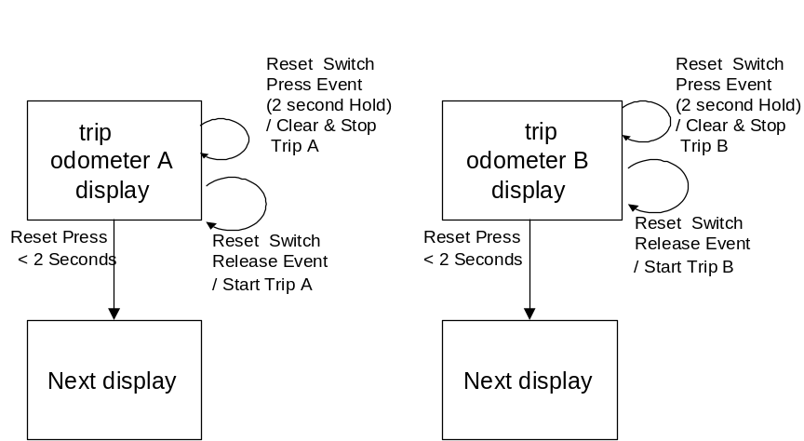

3-Button Trip Odo Reset Logic
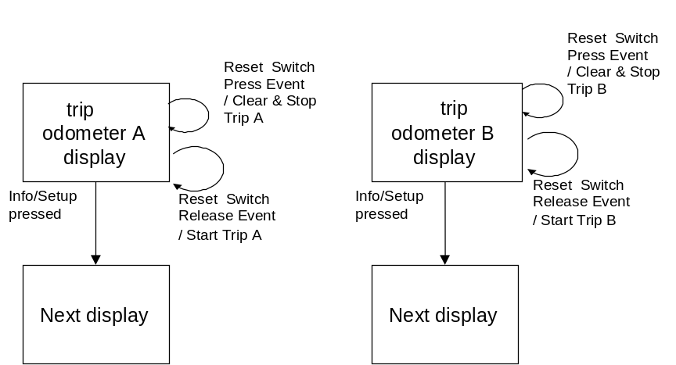

Additionally, for the Odometer Display with Key = OFF/ACC feature, per section 1.3.5.2:
- A Switch Press Event while the Door_Ajar_State_Change Timer is Active will start the Odo Timer. While the Odo Timer is active, the Odometer will be displayed.

System Accuracy

- The total odometer reading shall be within +/- 2 percent of the actual distance traveled by the vehicle.
- Shall use miles to kilometer conversion constant of 1.6093
- Shall not lose/gain more than 1 mile at battery disconnect
- Odometer algorithm shall introduce less that 0.1% error to displayed value

Operation: Performance and Functional

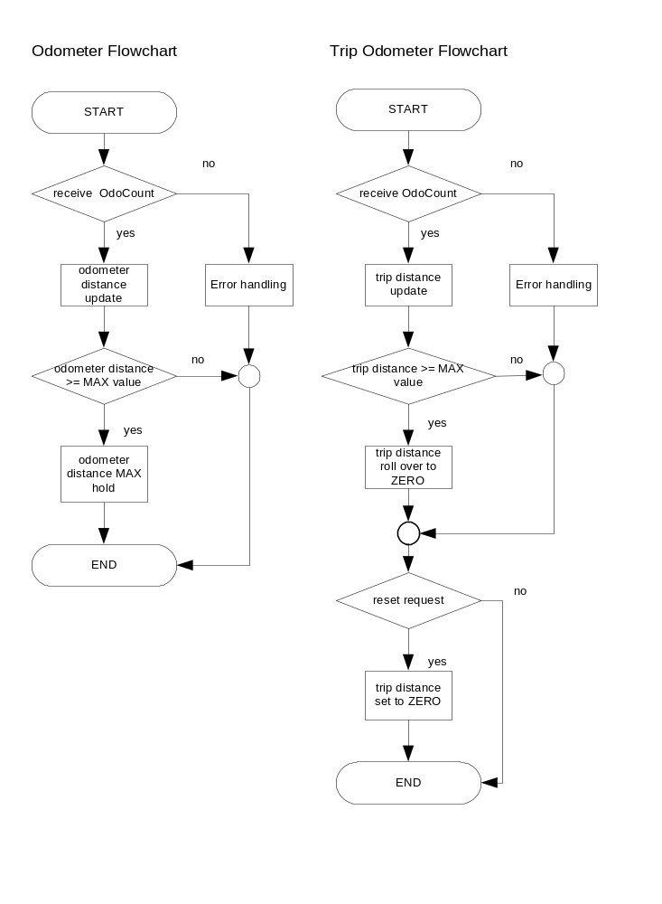Subsystem Algorithm Flowchart / State Diagram

Operation Description (supports algorithm flowchart /state diagram)

Operational Mode | NVM data validity | OdoCount Signal | MC Display
Sleep / Crank | X | X | No display
Normal / Limited | Corrupted | X | "Error"
Normal / Limited | Valid | Declared missing or invalid | "-------"
Normal / Limited | Valid | Valid | Normal display

ODOMETER
- The total odometer shall display the total accumulated vehicle distance traveled and shall not be able to be reset by the operator.
- Shall update the TOTAL accumulated distance from the OdoCount signal data received and shall not skip any digits on the display when incrementing
- Shall provide non-volatile memory storage for TOTAL distance such that it is tamper resistant
- Shall have redundant Total Odometer storage in NVM
- Shall display the Total Odometer as the default display following a battery disconnect/connect
- During key on, the odometer shall undergo prove-out, and then shall come up with last valid display prior to last key off cycle
- The TOTAL display shall not roll over to zero when the maximum accumulated value has been reached but instead continue to display the maximum value
- Display units shall default to speedometer units at battery connect and shall be user selectable, which is retained through key-on / key off cycle.
- Shall display "mi" indicator whenever the TOTAL display is in English (miles) mode
- Shall display "km" indicator whenever the TOTAL display is in metric (kilometers) mode
- A 7 digit odometer showing tenths is preferred, however, if a six digit display is used, TOTAL distance shall display a tenths digit (XX XXX.X) for values up to and including 99999.9. For values of 100000 and beyond, it shall display a hundred-thousands digit (XXX XXX) and suppress the tenths digit and decimal point. A decimal point will be lit and used in the appropriate position whenever tenths are displayed.
- The total odometer shall be updated via the Ford Diagnostic System as per the specification for this updating function.
- Odometer shall suppress all leading zeros, except for the ones digit.
- Total Odometer values shall be stored in a minimum of 6 NVM locations to insure read/write cycles do not wear out NVM up to maximum odometer mileage capability. The odometer shall continue to function with one or more of the NVM locations failing although integrity of the odometer value must be ensured. A sequence of odometer values shall be stored with or without redundancy. Odometer integrity shall be checked by validating the sequence and any redundancy if present.

TRIP ODOMETER
- Shall reset trip odometer to 0.0 when the Trip Odometer is displayed and the Reset Switch is held for 2 seconds on a 1-Button system and depressed on a 3-Button system. Trip Odometer will begin accumulating distance upon the switch release after a reset.
- Shall update Trip odometer from the CAN message OdoCount signal data and display shall not skip any digits including tenths while incrementing.
- Preferred maximum displayable accumulated value for a trip odometer is 9999.9 and shall be no less than 999.9.
- Trip odometer shall roll over to zero when the maximum displayable accumulated value has been reached, and then shall increment as normal. Preferred method for calculating trip odometer is to save the total odometer value at the start of the accumulating of trip odometer after a reset and subtracting that value from the current odometer value. With this method, the display can rollover repeatedly without a RESET and can be retained through Display Unit changes.
- Display units shall default to speedometer units at battery connect and shall be user selectable, which is retained through key-on / key off cycle.
- Trip odometer shall suppress all leading zeros, except for the ones digit.
ODOMETER Display with Key = OFF/ACC
- The Door_Ajar_State_Change Timer shall become active when the Operational_Mode changes to LIMITED from NORMAL or CRANK.
- The Door_Ajar_State_Change Timer shall become active when any door ajar state changes value or if the timer is already active the timer shall be cleared and restarted.
- The Door_Ajar_State_Change Timer shall stop when expired or when the Operational_Mode is not LIMITED.
- An active Door_Ajar_State_Change Timer shall not allow the transition to Operational_Mode equal SLEEP.
- The Odo Timer shall become active when:
- (The Door_Ajar_State_Change Timer is ACTIVE) AND (The RESET Switch on a 1-Button System or Any Message Center Switch on a 3-Button or 5-Button System is PRESSED)
- The Odo Timer shall be cleared and restarted when:
- (Odo Timer is Active) and (There is a transition to “No Active Not-Reset Limited Mode Warnings”)
- The Odo Timer shall be stopped and cleared when:
- (Operational_Mode is NOT equal to LIMITED) OR (Odo Timer is Expired)
- The Odometer Display with Key = OFF/ACC will be active when:
- (Odo Timer is Active) and (There are “No Active Not-Reset Limited Mode Warnings”)

Function Safety Classification (EMC)

Class B

Memory Storage

Description | Scope of Storage | Range | Units | Resolution | Init Value
Odometer | EEPROM (multiple) | 0xFFFFFF | Miles | >= 1/8000 mi and <= 0.1 km | 0x00
Odo_Trip_A | EEPROM* | 0xFFFFFF | Miles | >= 1/8000 mi and <= 0.1 km | 0x00
Odo_Trip_B | EEPROM* | 0xFFFFFF | Miles | >= 1/8000 mi and <= 0.1 km | 0x00
* Some legacy clusters have this in Battery Backed RAM.

 |  |  | Timers shall be programmable within the following range : *
Timer Name | Duration | Description | Min | Max | Resolution
Odo Timer | 10 s | Display duration of Odometer-Only display when operational mode = Limited | 0 s | 255 s | 1 s
Door_Ajar_State_  Change Timer | 35 min | Timer used to enable reading of Message Center switches for limited time after entering Limited mode. Enables message center switch input for Odo Only display. Timer restarted with Door Ajar input state change. | 0 min | 35 min | 5 min
* Note: Timers must be programmable to at least the Max value listed. Higher Max values and finer resolutions are acceptable.

Prove Out

Reference Message Center Display Section in this SPSS

Reconfigurable Telltale

No.

Message Center Msg

Message Center Text for Odometer, Trip Odometer A and Trip Odometer B

Error Handling

Odometer Error Handling
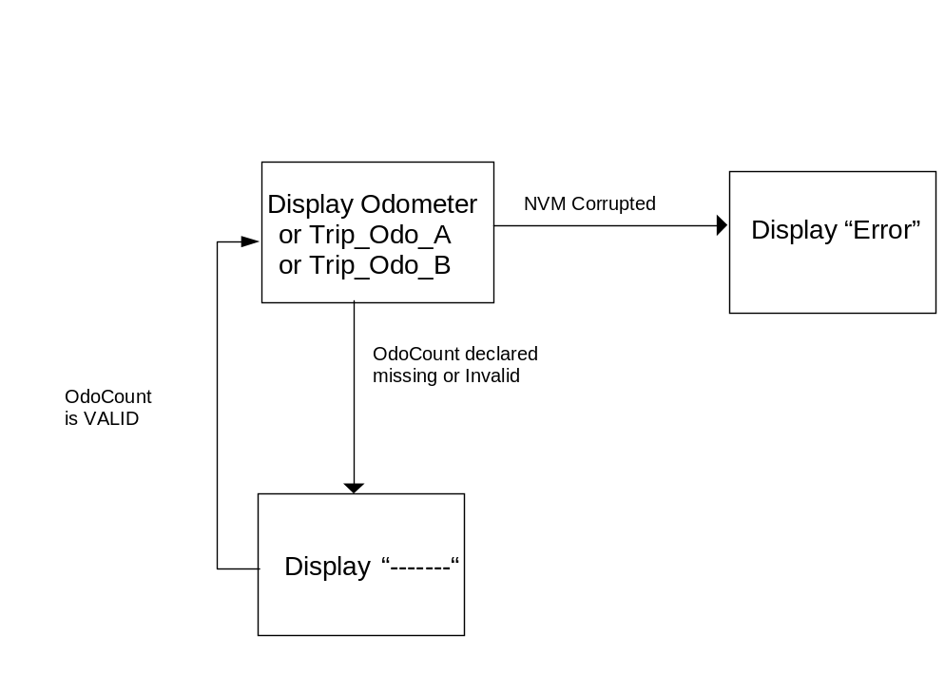

Missing Message Strategy

Missing Message DTCs can only be logged when DTC_Possible is TRUE. The definition of when DTC_Possible is TRUE is defined in the Diagnostics Section of this SPSS.

The signals will be declared missing as per the Diagnostics section of this SPSS.

DTCs states and history will be determined as per the Diagnostics section of this SPSS.

Diagnostics

The vehicle TOTAL accumulated distance displayed shall be settable to the actual vehicle distance traveled by standard Ford service center programming tools to support cluster replacement procedures.

Self Test

None.

Engineering Test Mode

None.

Part II Performance

Supported Mode $B1 Diagnostic Commands
Number | Command Name | Command Type
N/A | See odometer security access specification

Supported Diagnostic DIDs
Number | DID / CommonID Name | DID Type
0x404C | Odometer Store – High Resolution | UnsignedNumeric

Supported Diagnostic Trouble Codes (DTCs)
DTC | Description
C10000 | Lost communication with ECM/PCM
F000046 | Control Module – Data Memory Failure

Service

Vehicle odometer must be capable of being reset to a stated vehicle mileage prior to service installation and within 24 hours of dealer request.

Reference Specification
ODO Accy. IS-0100
ODO Accum. IS-0107
Trip Dist. Accy. IS-0307
Odo - Tamper Resist. IS-0332
Odo - Service IS-0335

Revision History

SPSS Module Revision History

Revision Level | Name | Change Description | Date
1.0 | V. Patel | Updated for CGEA 1.3 based on CGEA STSS v1.0  Section 1.2.2 – Removed table referencing the HS-CAN message that contains the input signals.  Section 1.2.3 – Removed table referencing the HS-CAN message that contains the output signals.  Section 1.4 –Rewrote definition for missing and invalid message strategy. Modified Odometer Error Handling figure.  Section 1.5.3 – Deleted DTC logging criteria from the table. | 4/28/2010

